Design matrix

Alias

design matrix

model matrix

regressor matrix

Intro

In regression analysis, a design matrix is a matrix of values of explanatory variables of a set of objects.

Def

Examples

Arithmetic mean



Simple linear regression

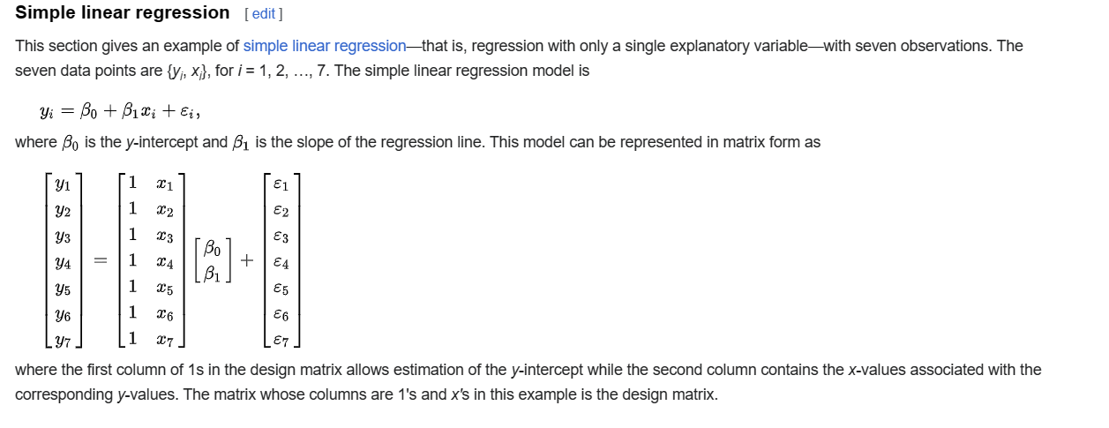

Multiple regression

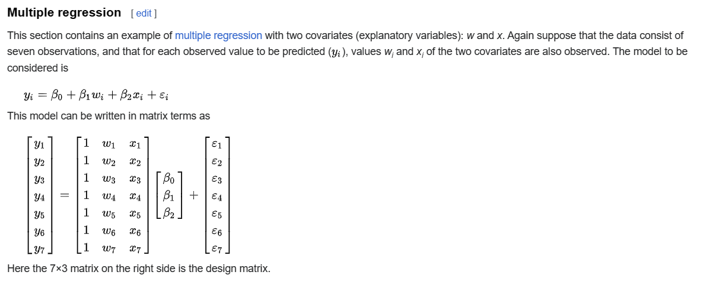

One-way ANOVA (cell means model)

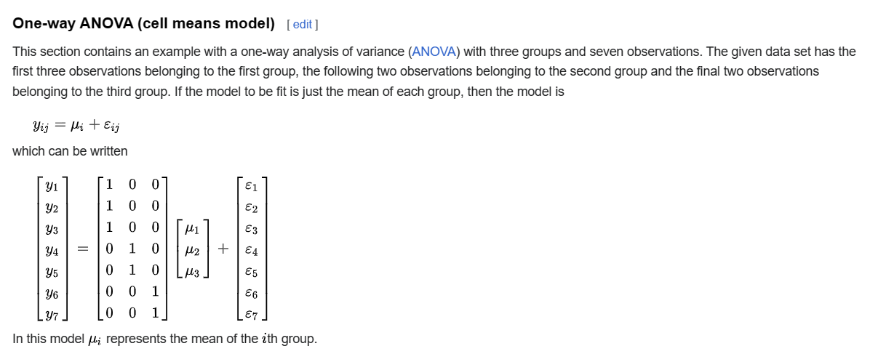

One-way ANOVA (offset from reference group)

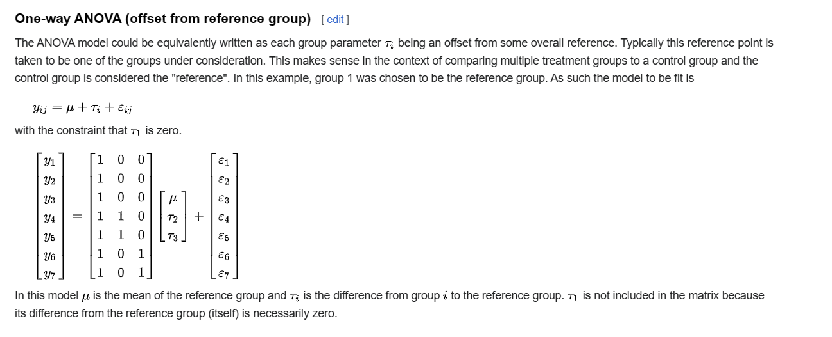

Ref

[Design matrix - Wikipedia](https://en.wikipedia.org/wiki/Design_matrix)